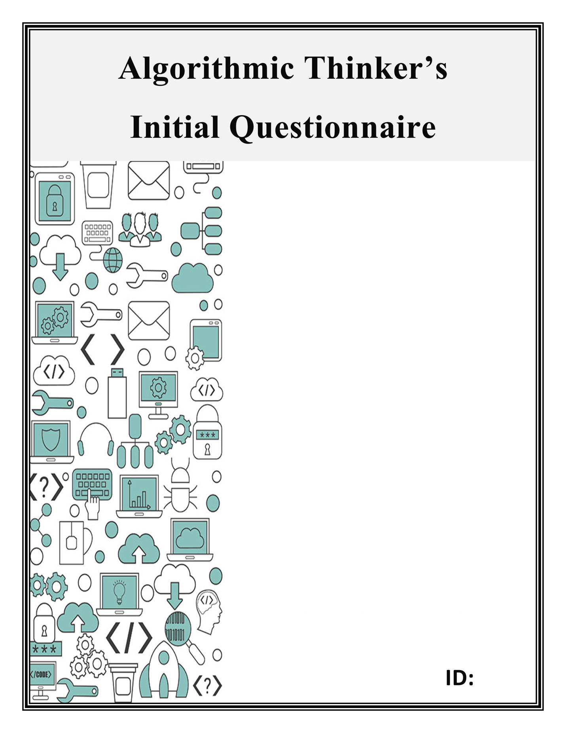

Dear parent or guardian:

As part of the Algorithmic Thinking study, we are asking you and your child to fill out this questionnaire. There are three parts, but altogether the it shouldn’t take more than 10 minutes to complete. Be sure to first read the introductory letter that came with the questionnaire so you and your child understand the purpose of the study and the nature of the enrichment activity involved.

Be sure also to carefully read the Informed Consent parental permission form and the Child Assent form that came with this survey. For your child to participate in the study, you will need to sign the Informed Consent form and initial each page, and your child will need to read and sign the Child Assent form.

The first part of the survey asks about the gender and year in school of your child. The last two parts ask your child to think about different high school courses and possible work after high school. These questions are asked from your child’s point of view. What does he or she think about these courses and types of work?

Thank you for your kind consideration.

**Initial Questionnaire**

1. What is the gender of your child? M / F / other _______
2. What year in school is your child? ___________________

**Next, we’d like to ask about future plans**

These questions are asked from your child’s point of view. If your child needs some help interpreting these questions, that’s OK, but we ask that he or she answer the questions directly.

1. Maybe you’ve already thought about what **courses you want to take in high school**. Maybe not! Take a minute to think about that. Then look at these possible high school courses and rate your interest in them.

|  |  |  |
| --- | --- | --- |
| Which of these high school courses might you take? | | |
|  | Calculus (an advanced math course) | |  |  |  |  | | --- | --- | --- | --- | | Absolutely not |  |  | Absolutely yes | | 1 | 2 | 3 | 4 | |
|  | Physics (an advanced science course) | |  |  |  |  | | --- | --- | --- | --- | | Absolutely not |  |  | Absolutely yes | | 1 | 2 | 3 | 4 | |
|  | Trigonometry (an advanced math course) | |  |  |  |  | | --- | --- | --- | --- | | Absolutely not |  |  | Absolutely yes | | 1 | 2 | 3 | 4 | |
|  | A second year of chemistry (an advanced science course) | |  |  |  |  | | --- | --- | --- | --- | | Absolutely not |  |  | Absolutely yes | | 1 | 2 | 3 | 4 | |
|  | Computer programming | |  |  |  |  | | --- | --- | --- | --- | | Absolutely not |  |  | Absolutely yes | | 1 | 2 | 3 | 4 | |
|  | Engineering | |  |  |  |  | | --- | --- | --- | --- | | Absolutely not |  |  | Absolutely yes | | 1 | 2 | 3 | 4 | |
|  | Accounting | |  |  |  |  | | --- | --- | --- | --- | | Absolutely not |  |  | Absolutely yes | | 1 | 2 | 3 | 4 | |

1. Maybe you’ve already thought about what you want to **do after high school**, say go on to college or start work. Maybe not! Take a minute to think about what you would like to do after high school. Then look at these possible fields of work or study and rate your interest in them.

|  |  |  |
| --- | --- | --- |
| Can you see yourself studying or working in any of these fields after high school? | | |
|  | Computer science | |  |  |  |  | | --- | --- | --- | --- | | Absolutely not |  |  | Absolutely yes | | 1 | 2 | 3 | 4 | |
|  | Physics | |  |  |  |  | | --- | --- | --- | --- | | Absolutely not |  |  | Absolutely yes | | 1 | 2 | 3 | 4 | |
|  | Chemistry | |  |  |  |  | | --- | --- | --- | --- | | Absolutely not |  |  | Absolutely yes | | 1 | 2 | 3 | 4 | |
|  | Mathematics | |  |  |  |  | | --- | --- | --- | --- | | Absolutely not |  |  | Absolutely yes | | 1 | 2 | 3 | 4 | |
|  | Programming | |  |  |  |  | | --- | --- | --- | --- | | Absolutely not |  |  | Absolutely yes | | 1 | 2 | 3 | 4 | |
|  | Engineering | |  |  |  |  | | --- | --- | --- | --- | | Absolutely not |  |  | Absolutely yes | | 1 | 2 | 3 | 4 | |
|  | Accounting | |  |  |  |  | | --- | --- | --- | --- | | Absolutely not |  |  | Absolutely yes | | 1 | 2 | 3 | 4 | |